Clinic Date

Sincerely

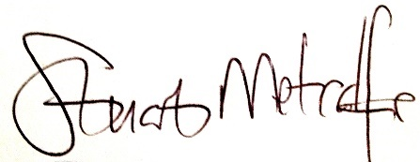

Mr S A Metcalfe BSc(Hons), MPhil, FCPodS

Consultant Podiatric Surgeon

ALL CORRESPONDENCE TO:

Redwood House, Pikes Hill Avenue, Lyndhurst, SO43 7AX

